
Tripoli Motor Testing Division
223 NC Highway 54 West
Chapel Hill, NC 27514
(919) 357 5681 (c)
June 3, 2002

Gary Rosenfield
RCS Rocket Motor Components, Inc.
2113 West 850 North Street
Cedar City, UT 84721

Dear Mr. Rosenfield,

The Q-jet by Aerotech F41W single-use motor was tested on April 29, 2022 and June 2, 2022 and complies with NFPA 1125. The motor is certified for hobby rocketry use by the members of the Tripoli Rocketry Association and all approving organizations with reciprocal certifying agreements.

Motor Manufacturer RCS Rocket Motor Components, Inc.
Manufacturer’s Designation {F41-5,8,11W } [single use]
Propellant White Lightning
TMT Nomenclature 45 F40

Diameter 0.935” 23.76 mm
Overall Length 4.498” 114.25 mm
Outside the MMT 0.191” 4.85 mm

Loaded Mass 0.134 lb 60.70 g
Propellant Mass 0.0661 lb* 30.0 g*
Burnout Mass 0.057 lb 25.87 g
* = data provided by manufacturer

Burn time 1.118 ± 0.251 sec

Total Impulse 10.205 ± 2.287 lbf.s 45.40 ± 10.17 N.s
Max Impulse 11.219 ± 2.626 lbf 49.94 ± 11.68 N
Average Impulse 9.054 ± 2.071 lbf 40.26 ± 9.21 N
Number of Motors Tested 14

Nominal Measured
Delay Time Data 5 s 4.586,4.849, 5.044, 4.909 s
8 s 7.592, 6.894, 6.778, 7.178 s
11 s 9.448, 9.732, 10.028, 8.872, 9.265, 8.938 s

Casing Temp. [NFPA 1125 7.4.1] Passed

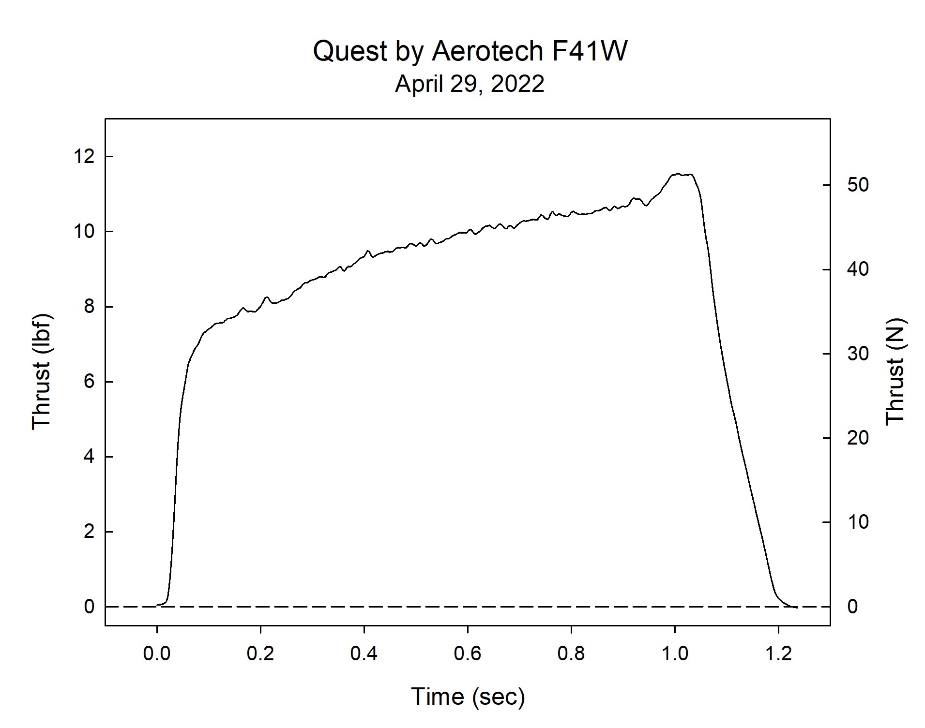

Sincerely,

Alan C. Whitmore
Chair, Tripoli Motor Testing

